Digital humanities project (Models)  
  
Hedy Lamarr  
  
METADATA ANALYSIS

| # | Item type | Example | Provider | Metadata standard |
| --- | --- | --- | --- | --- |
| 1 | Algiers (1938) | Film | IMDb | Schema.org |
| 2 | Samson and Delilah (1949) | Film | Library of Congress | MARC21 |
| 3 | Secret Communication System (US Patent 2,292,387) | Patent | USPTO | XML (EPO/Patent Office Standard) |
| 4 | Come Live with Me (1941) | Film | TCM | Schema.org |
| 5 | Bombshell: The Hedy Lamarr Story (2017) | Film | Europeana | EDM (Europeana Data Model) |
| 6 | Boom Town (1940) | Film | BFI | MARC21 |
| 7 | Hedy Lamarr Portrait (1940s) | Photograph | Getty Images | VRA Core |
| 8 | Ecstasy (1933) | Film | Deutsche Kinemathek | CIDOC CRM |
| 9 | Hedy Lamarr: The Most Beautiful Woman in Film | Biographical Text | Internet Archive | Dublin Core |
| 10 | Ziegfeld Girl (1941) | Film | Wikidata | RDF (Wikidata Properties) |
| 11 | Hedy Lamarr’s FBI File (Declassified) | Archival Document | U.S. National Archives | EAC-CPF |
| 12 | The Heavenly Body (1944) | Film | MGM Archives / Warner Bros. | PBCore |
| 13 | Frequency Hopping (Tech Demonstration) | Audio Recording | Stanford University Archives | MODS |
| 14 | Dishonored Lady (1947) | Film | Internet Archive / Public Domain Archives | Dublin Core |
| 15 | The Strange Woman (1946) | Film | Film Noir Foundation / Criterion Collection | Schema.org |

Each identified metadata standard name has a link to the page where the provider declares its use.

(a) indicates that the standard has been applied by us because the provider has no statement about it.

METADATA ALIGNMENT  
  
WHO

| Property | DCTerms | MMD | Schema.org | MARC21 | CDWA |
| --- | --- | --- | --- | --- | --- |
| Creator | creator | <artist><name> | CreativeWork.creator | 100 1#$a | Creator description |
| Publisher | publisher | <label> | CreativeWork.publisher | 264 #0$b | Creator identity |
| Contributor | contributor | <name><namePart> | CreativeWork.contributor | 700 1#$a | Creator Role |
| Institution | rightsHolder | N/A | CreativeWork.archivedAt | 561 $5 | Owner/Agent |

WHERE

| Property | DCTerms | MMD | Schema.org | MARC21 | CDWA |
| --- | --- | --- | --- | --- | --- |
| Place of Production | coverage.spatial | <place-list><place-element> | Movie.countryOfOrigin | 264 #0$a | Creation Place/Original Location |
| Current Location | LocationPeriodOrJurisdiction | N/A | Place | 852 $a | Current Location Description |
| Place Depicted | coverage.spatial | N/A | CreativeWork.contentLocation | 651 $a | Place/Location Label |

WHEN

| Property | DCTerms | MMD | Schema.org | MARC21 | CDWA |
| --- | --- | --- | --- | --- | --- |
| Creation Date | date.created | <release><date> | CreativeWork.dateCreated | 264 #0$c | Creation Date |
| Publication Date | date.issue | N/A | CreativeWork.datePublished | 264 #1$c | Date Qualifier |
| Period Depicted | coverage.temporal | N/A | CreativeWork.temporalCoverage | 045 | Styles/Periods |

WHAT

| Property | DCTerms | MMD | Schema.org | MARC21 | CDWA |
| --- | --- | --- | --- | --- | --- |
| Title | title | <release><title> | Thing.name | 130 $a | Title Text |
| Identifier | identifier | <track.id> | Thing.identifier | 020-024 | Repository Numbers |
| Description | description | N/A | Thing.description | 3XX | Descriptive Note |
| Subject | subject | N/A | CreativeWork.about | 6XX | Subject Display |
| Language | language | <work><language-list> | CreativeWork.inLanguage | 041 | Inscription Language |
| Technique | type | <genre-list><genre> | CreativeWork.genre | 340 $d | Materials/Techniques |

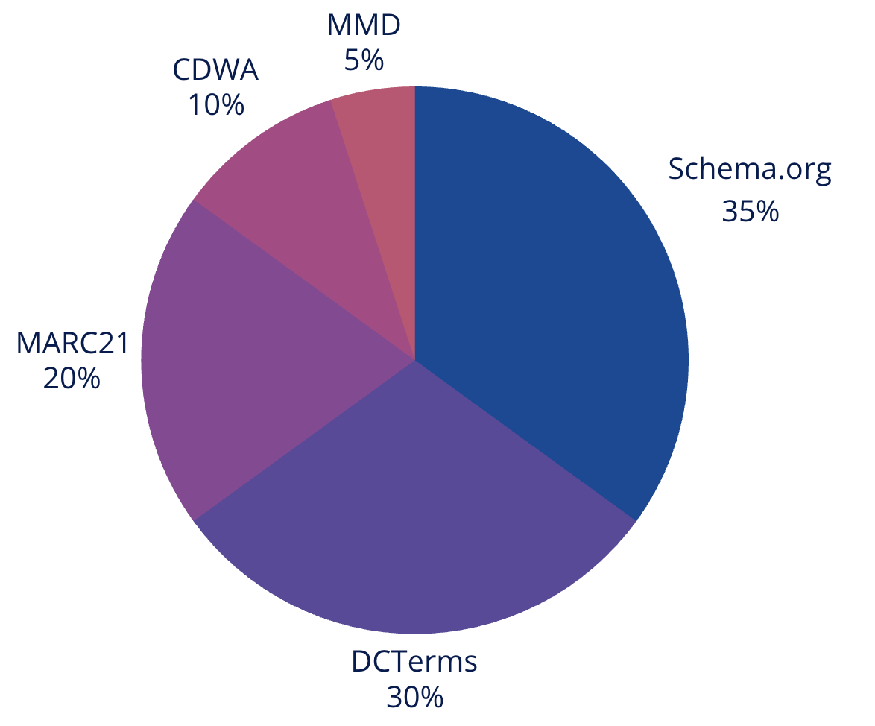

THEORETICAL MODEL

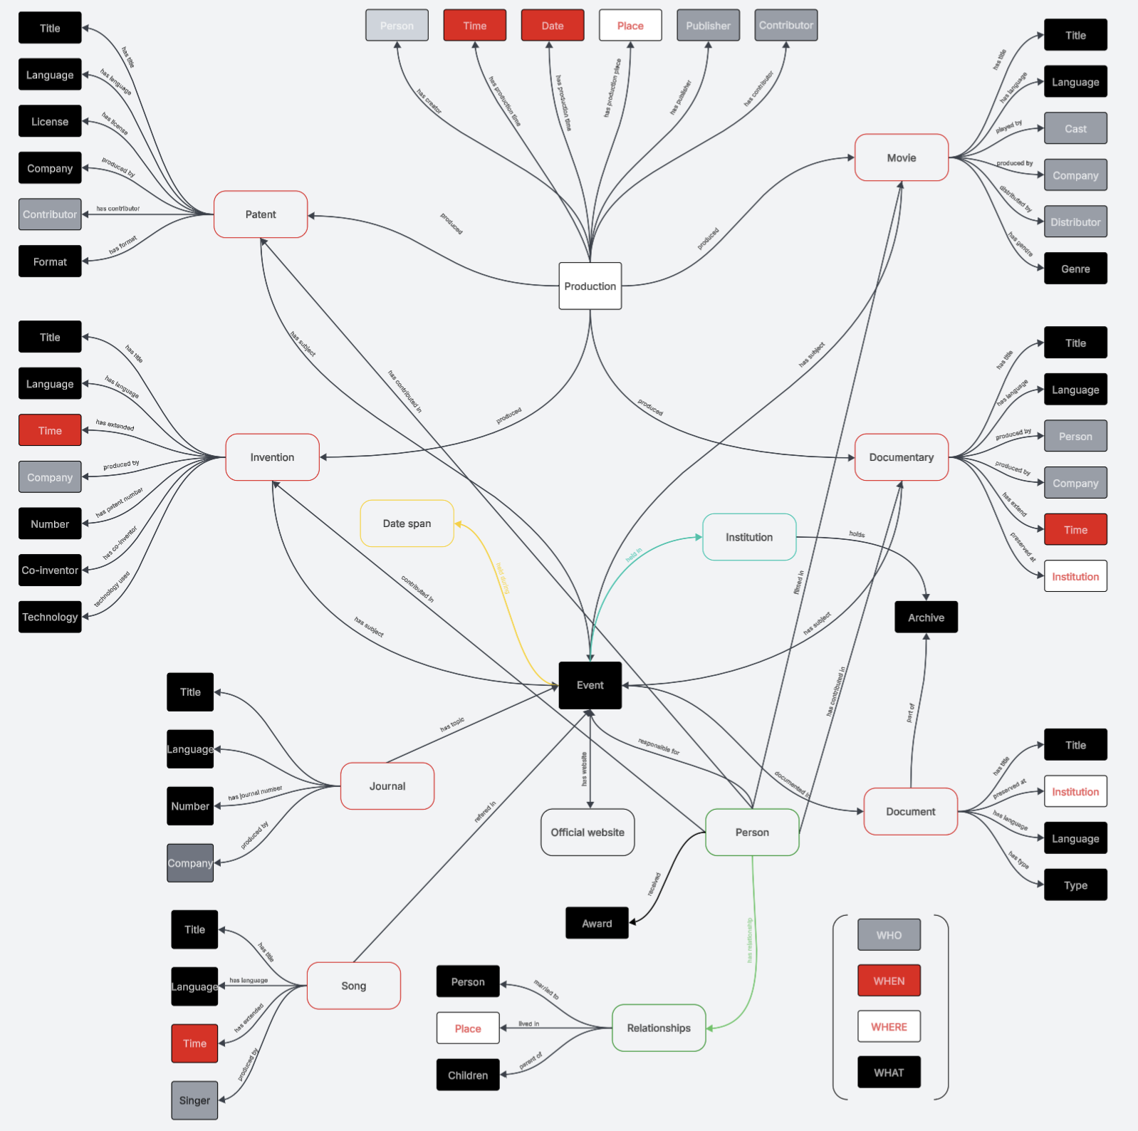

ENHANCED E/R MODEL

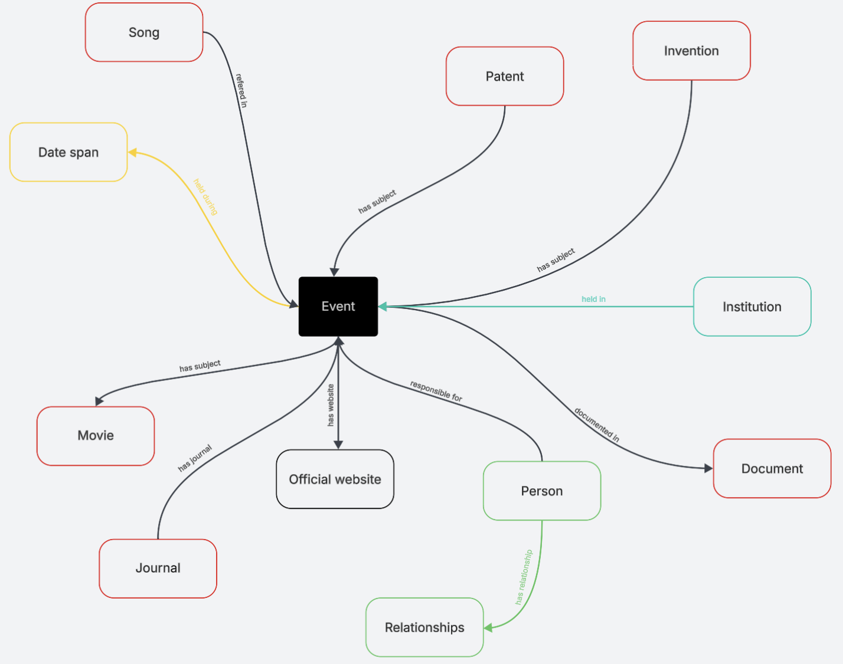

RELATIONAL THEORETICAL MODEL

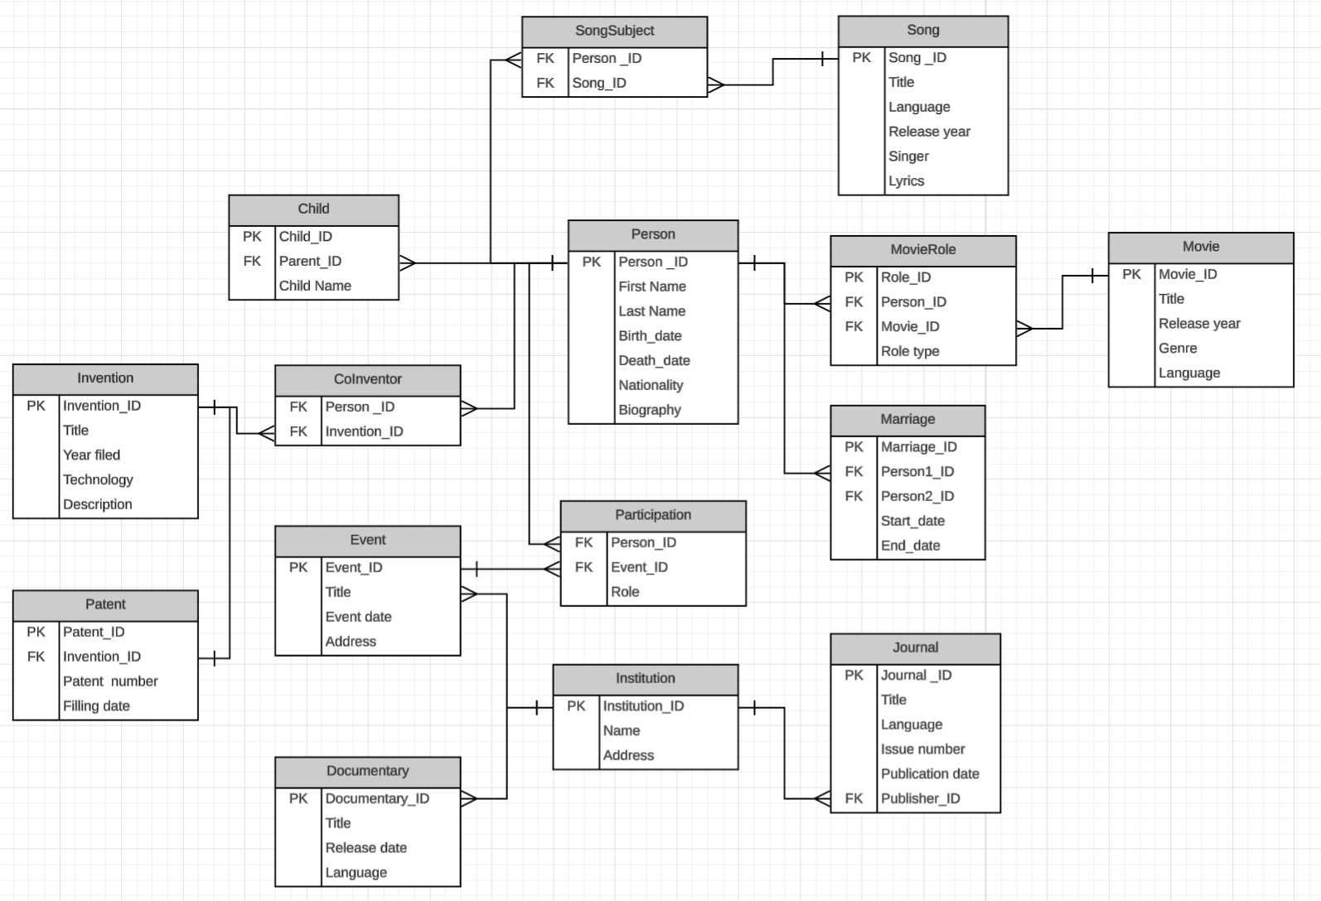

CONCEPTUAL MODEL

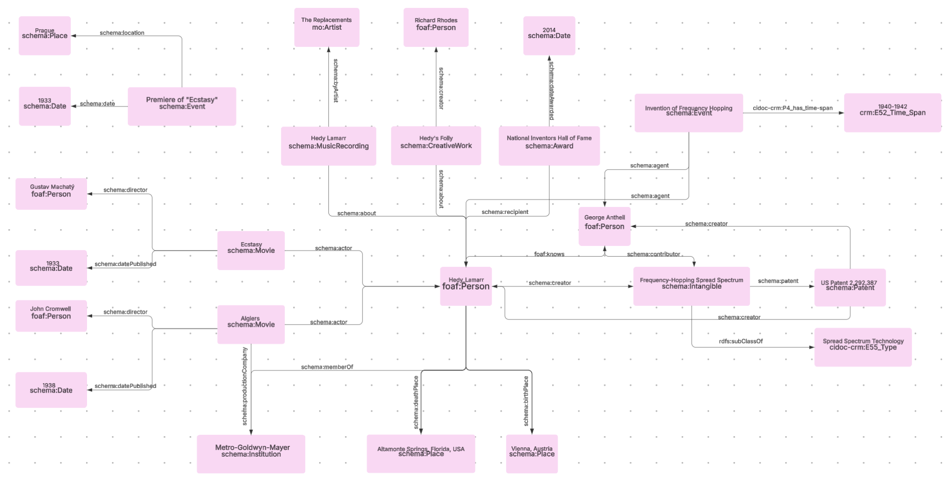  
DATA DESCRIPTION  
  
PERSON

| Subject | Predicate | Object |
| --- | --- | --- |
| HedyLamarr | rdf:type | foaf:Person |
| HedyLamarr | rdf:type | schema:Person |
| HedyLamarr | foaf:name | "Hedy Lamarr" |
| HedyLamarr | foaf:givenName | "Hedwig Eva Maria" |
| HedyLamarr | foaf:familyName | "Kiesler" |
| HedyLamarr | schema:alternateName | "Hedy Lamarr" |
| HedyLamarr | schema:birthDate | "1914-11-09" |
| HedyLamarr | schema:birthPlace | Vienna_Austria |
| HedyLamarr | schema:deathDate | "2000-01-19" |
| HedyLamarr | schema:deathPlace | AltamonteSprings_Florida |
| HedyLamarr | schema:nationality | "Austrian-American" |
| HedyLamarr | schema:occupation | "Actress" |
| HedyLamarr | schema:occupation | "Inventor" |
| HedyLamarr | schema:knows | GeorgeAntheil |
| HedyLamarr | schema:award | NationalInventorsHallOfFame_Award |
| HedyLamarr | schema:memberOf | MGM_Organization |
| HedyLamarr | schema:alumniOf | MaxReinhardtSeminary |
| HedyLamarr | schema:url | Wikipedia_HedyLamarr |
| HedyLamarr | schema:url | IMDb_HedyLamarr |

INVENTION

| Subject | Predicate | Object |
| --- | --- | --- |
| FrequencyHoppingSpreadSpectrum | rdf:type | schema:Intangible |
| FrequencyHoppingSpreadSpectrum | rdf:type | cidoc-crm:E28_Conceptual_Object |
| FrequencyHoppingSpreadSpectrum | schema:name | "Frequency-Hopping Spread Spectrum" |
| FrequencyHoppingSpreadSpectrum | schema:creator | HedyLamarr |
| FrequencyHoppingSpreadSpectrum | schema:creator | GeorgeAntheil |
| FrequencyHoppingSpreadSpectrum | schema:dateCreated | "1941" |
| FrequencyHoppingSpreadSpectrum | schema:description | "A method for securely controlling torpedoes..." |
| FrequencyHoppingSpreadSpectrum | schema:patent | US_Patent_2292387 |
| FrequencyHoppingSpreadSpectrum | rdfs:subClassOf | SpreadSpectrumTechnology_Type |

PATENT

| Subject | Predicate | Object |
| --- | --- | --- |
| US_Patent_2292387 | rdf:type | schema:Patent |
| US_Patent_2292387 | rdf:type | bibo:Patent |
| US_Patent_2292387 | schema:name | "Secret Communication System" |
| US_Patent_2292387 | schema:identifier | "US 2,292,387" |
| US_Patent_2292387 | schema:datePublished | "1942-08-11" |
| US_Patent_2292387 | schema:assignee | National_Inventors_Council |
| US_Patent_2292387 | ag:isSubjectOf | PatentAgreement_Concept |
| US_Patent_2292387 | schema:url | "https://patents.google.com/patent/US2292387" |

MOVIE

| Subject | Predicate | Object |
| --- | --- | --- |
| Ecstasy_Movie | rdf:type | schema:Movie |
| Ecstasy_Movie | dcterms:title | "Ecstasy" |
| Ecstasy_Movie | dcterms:language | "de" |
| Ecstasy_Movie | schema:actor | HedyLamarr |
| Ecstasy_Movie | schema:director | GustavMachaty |
| Ecstasy_Movie | schema:datePublished | "1933" |
| Ecstasy_Movie | schema:countryOfOrigin | Czechoslovakia |

AWARD

| Subject | Predicate | Object |
| --- | --- | --- |
| NationalInventorsHallOfFame_Award | rdf:type | schema:Award |
| NationalInventorsHallOfFame_Award | schema:name | "National Inventors Hall of Fame Inductee" |
| NationalInventorsHallOfFame_Award | schema:recipient | HedyLamarr |
| NationalInventorsHallOfFame_Award | schema:dateAwarded | "2014" |

PLACE

| Subject | Predicate | Object |
| --- | --- | --- |
| Vienna_Austria | rdf:type | schema:Place |
| Vienna_Austria | schema:name | "Vienna" |
| Vienna_Austria | schema:containedInPlace | Austria |

CREATIVE WORK ABOUT HEDY LAMARR

| Subject | Predicate | Object |
| --- | --- | --- |
| HedysFolly_Book | rdf:type | schema:Book |
| HedysFolly_Book | dcterms:title | "Hedy's Folly: The Life and Breakthrough Inventions of Hedy Lamarr" |
| HedysFolly_Book | schema:creator | RichardRhodes |
| HedysFolly_Book | schema:about | HedyLamarr |
| HedysFolly_Book | schema:datePublished | "2011" |
| HedysFolly_Book | dcterms:language | "en" |